SESSION 3
Greetings/  Icebreaker RECAP from last session  Follow up on action plans | Instruction: Similar to last week’s session, use coloured “Holi” powder to make a large circle, large enough to allow all participants to sit comfortably inside. Ensure the area is clean and neat. You can also put down a mat or blanket to sit on if appropriate. Invite some of the mothers to help create the design as well. Make sure the hand washing facility if filled with water and there is soap available.  Greet mothers and children and ask them sit in the circle of cleanliness:  Promoter: “Remember, this beautiful circle that we have drawn isn’t just any circle, similar to last week’s session; we should imagine that it’s a very pure and clean place. So pure only mums with magic hands can enter.  What does it mean to have magic hands”? (A: Clean hands washed with soap and water). So who then amongst us do you think can enter the circle? For those who are not ready to enter, what would they need to do in order to have magic hands”? (A: Wash hands with soap and water).  Promoter: “Welcome to our third Mum’s Magic Hands Session. Now that we all have magic in our hands and are comfortable and clean in our circle of cleanliness, can anyone tell me what we discussed during our last session?” (Get mothers to share what they recall from previous session).  Promoter: “Now let’s reflect on our action plans from last week/last session. Is there anyone who would like to remind us what we planned to do to ensure we all have magic in our hands like the Magic Mum in the story and provide the best hand washing environment in our homes? (Probe for the action plan items that were recorded the previous week).  Instruction: Ask mothers whether they were able to overcome some of the challenges discussed during last week’s session.  Promoter: “What actions did you take in your home to ensure you and your children had magic in your hands and remembered to wash hands with soap like the mother and daughter in the story? What actions did you take to overcome (x, y, z) challenges from last week”?  Promoter: “Was anyone not able to follow through with any of the actions? Why? What are some of the challenges you faced since our last session in ensuring you and your family’s hands had magic in them?  Remind mothers of the scratch card exercise and ask if they’ve brought them to the session. If so, review last week’s progress (from Day 7-14). Discuss why on some of the days, the box on the card is still intact or why more than required have been scratchd off?  Instruction: Discuss challenges and ways to overcome them going forward. | Resources  Magic Hands Storyboard  Action plans from last session  Hand washing station  Soap, water  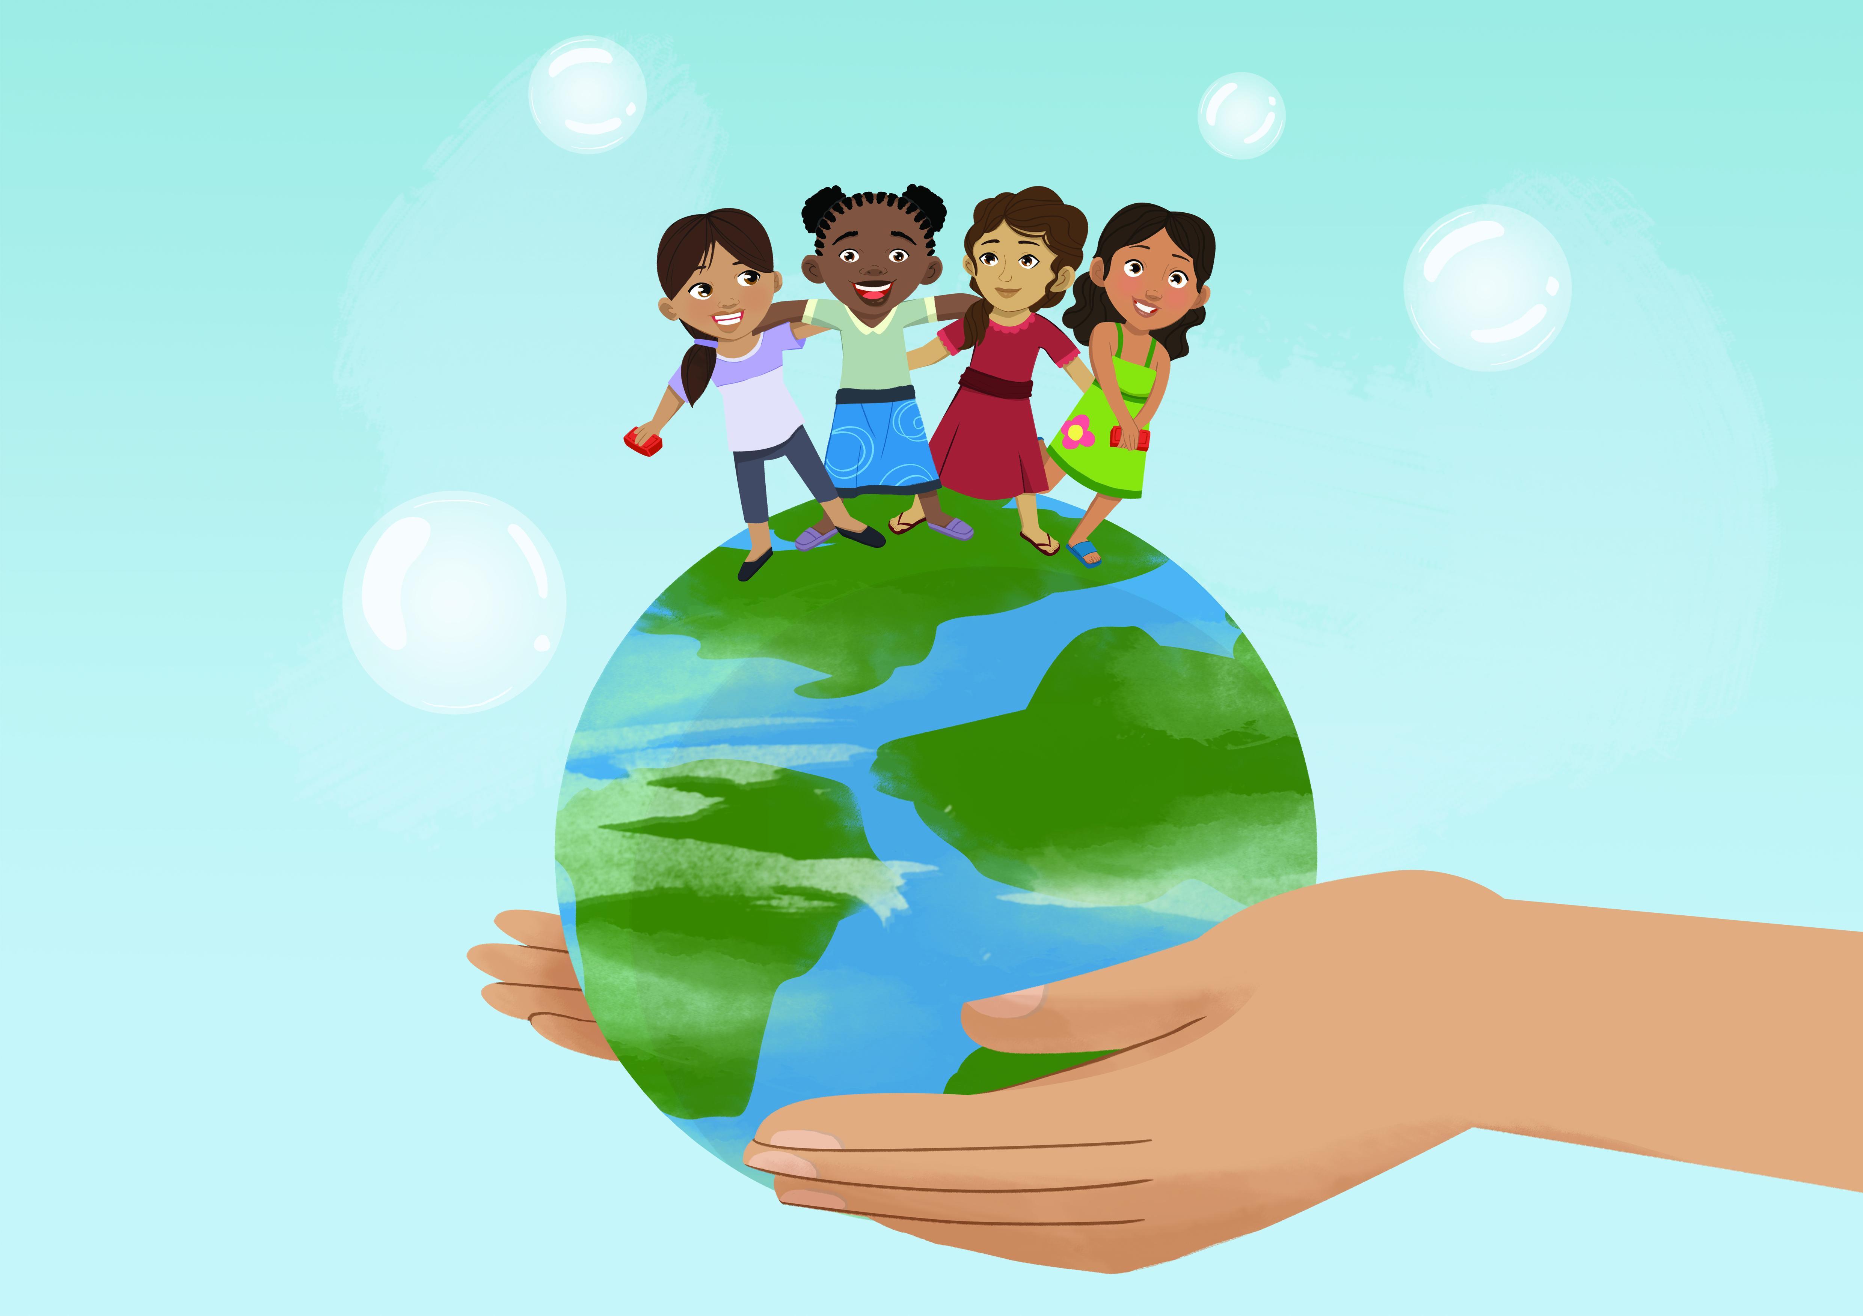
Monitoring Exercise | Instruction: Set up the 2 boxes in a discreet place where people can vote anonymously. You can put the boxes behind a curtain or in an appropriate place hidden away from the group so that they are not seen depositing their votes. You will use this in an exercise following the questions.  Promoter: “Remember the exercise we completed in the first 2 sessions with the hand washing box and the non hand washing box? We would like to conduct this exercise again”.  Instruction: Distribute 5 ballots to each mother.  Promoter: “As in previous sessions, we have set up 2 boxes; one blue one and one black. Remember, the blue box is the ‘HWWS soap and represents hands that have magic in them’ and the black one is the ‘non HWWS box and represents hands that are lacking the magic’.  PART 1: Again I’d like you to think about mothers in your community. For those of you who think mothers have magic in their hands before eating (i.e. are washing their hands with soap regularly at this key occasion), please place your ballot in the blue box or the ‘HHWS box’. For those of you who think that other mothers in your community lack magic in their hands before eating (not washing their hands with soap regularly on this key occasion), please place your ballot in the black box or the ‘non hand washing with soap box’.  PART 2: Again think about mothers in your community and their hand washing practice after using the toilet. For those of you who think mothers have magic in their hands and are washing their hands with soap regularly after using the toilet please place your ballot in the blue box or the ‘hand washing with soap box’. For those of you who think that mothers in your community lack magic in their hands or are not washing their hands with soap regularly after using the toilet, please place your ballot in the black box or the ‘non hand washing with soap box’.  PART 3: Again think about other mothers in your community. For those of you who think other mothers are washing their hands with soap regularly before feeding babies or young children please place your ballot in the blue box or the ‘hand washing with soap box’. For those of you who think that other mothers in your community are not washing their hands with soap regularly before feeding babies or young children, please place your ballot in the black box or the ‘non hand washing with soap box’.  PART 4: Again think about other mothers in your community. For those of you who think other mothers are washing their hands with soap regularly before preparing food place your ballot in the blue box or the ‘hand washing with soap box’. For those of you who think that other mothers in your community are not washing their hands with soap regularly before preparing food, please place your ballot in the black box or the ‘non hand washing with soap box’.  PART 5: Again think about other mothers in your community. For those of you who think other mothers are washing their hands with soap regularly after cleaning child faeces please place your ballot in the blue box or the ‘hand washing with soap box’. For those of you who think that other mothers in your community are not washing their hands with soap regularly after cleaning child faeces, please place your ballot in the black box or the ‘non hand washing with soap box’.  Instruction: Count the ballots in the blue box and then the black box and tell the participants you will follow up at the end of the session. | Resources  Notetaker  Ballots – 5 per participant  1 Blue Box with slot for voting  1 Black Box with slot for voting
Mum’s Magic Hands Storyboard Refresher | Instruction: Review “Mum’s Magic Hands” Storyboard by having one or two volunteer mothers from the group if willing present the story again. Help them to remember if they forget any key points. | Resources  Mum’s Magic Hands Storyboard.  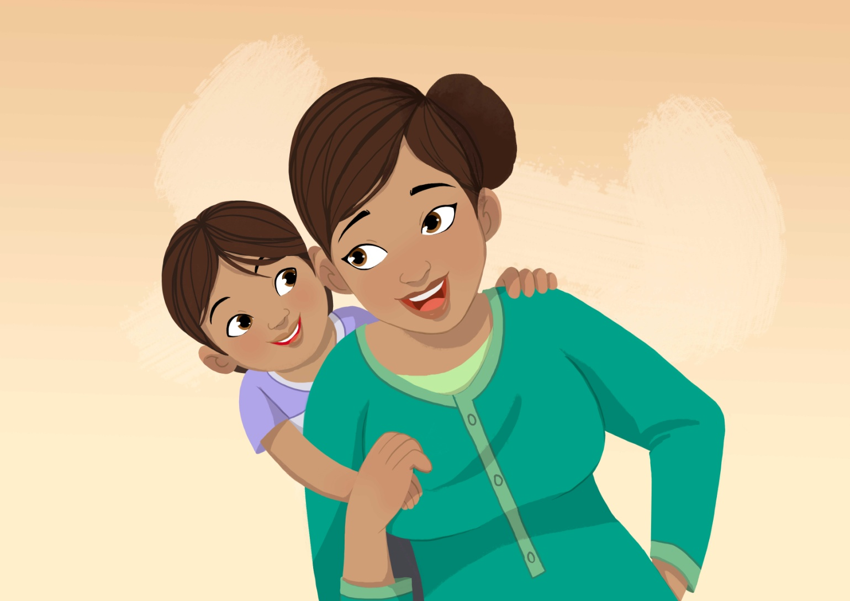
5 Key Times | Instruction: Show the A3 size image of Frame 15. Ask mothers to explain what they see in the image. Remind them of the script and how the daughter as a doctor is reminding all mothers to ensure their children wash their hands at 2 key times – before eating and after the toilet. Ask them about the other key times that are important for mothers.  Promoter: “Now let’s take a look at this image from the story again. What do you see in this picture?  Promoter: “Remember the little girl became a doctor and she is reminding us to ensure our children wash their hands before eating and after using the toilet. What are the other key times that are important for mothers?” (A: Before preparing food, before feeding children, after cleaning child faeces).  Instruction: When a participant recalls “before preparing food”, give her the image of preparing food and ask her to place it on the poster. Do the same for the other 2 key times (before feeding children, after cleaning child faeces). Then recap the key times one last time before continuing to the next session.  Promoter: “Yes before preparing food, well done Mrs X. Please place the picture onto the poster so that everyone can see it and be reminded of this important time. Yes before feeding children, well done Mrs Y. Please place the picture onto the poster so that everyone can see it and be reminded of this important time! Yes after cleaning child faeces, well done Mrs Z. Please place the picture onto the poster so that everyone can see it and be reminded of this important time! Mothers and children, please take a look at the images again to remind you of the most important times for hand washing! | Resources  Frame 15 (A3 Size)  Images from ballot box exercise:  - Feeding child  - Preparing food  - Cleaning child faeces/changing diaper  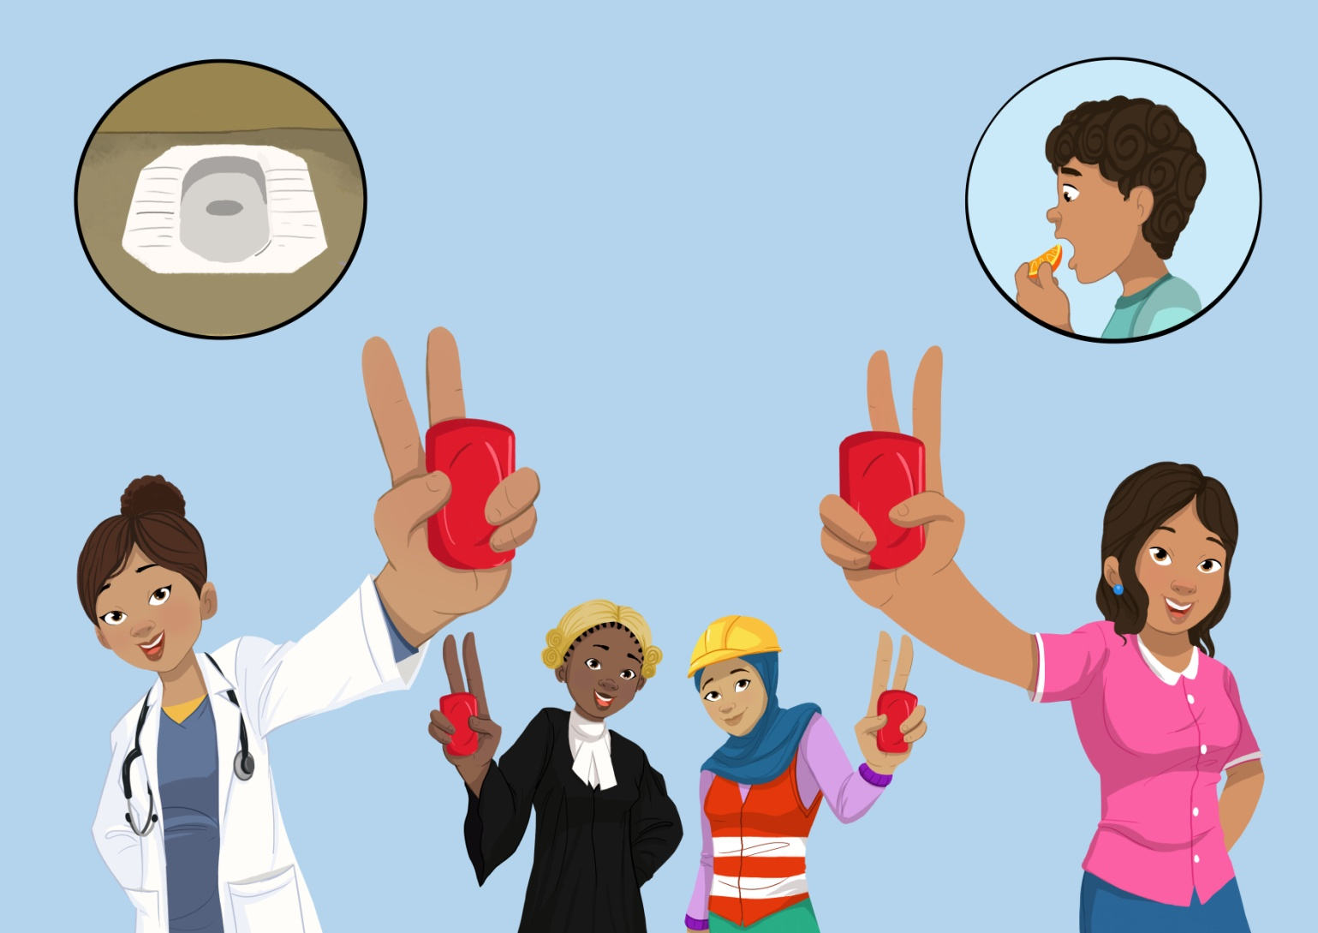
Routine Dial | Instruction: Place the clock on the ground where it is visible to everyone. Make sure the area is clean. Place the hand washing cards in one pile and the activity cards in another (near the clock). Introduce the exercise.  Promoter: “Now that the story of Mum’s Magic Hands is fresh in our minds, I’d like to ask the children to play a “Magic game.”  Instruction: Ask the children to gather around the clock and ask them what they think the images on the clock represent.  A: (Sunrise = morning, Sun overhead = afternoon, Sunset = evening, Moon out=night)  Now ask the children to think about some of the activities they do during these times.  Promoter: “Now that we understand what the different positions of the sun represent, can I have one volunteer who can tell me some of the activities they do at different points in the day? There are some pictures here which you can use to help you (point to the activity pile). If there are other activities you do, there are markers and paper here for you to make your own pictures. Please place them where you think they should go on the clock.”  Instruction: Once they have completed this exercise, ask the other children if there are any other activities they do that might be different. Have them fill in the clock with the appropriate cards.  Promoter: “Is there anyone else who would like to add any additional activities they do during the morning, afternoon or evening? If the picture is not in the pile, there are markers and paper that you can use to make your own pictures!”  Instruction: Now, point to the hand washing cards.  Promoter: “Can I have a volunteer who would like to show us at which times they practice hand washing with soap? Please take as many cards as you need and place them where you wash your hands with soap. For example, if you wash your hands with soap after playing, place a card after the playing picture”. (Demonstrate this).  Instruction: As the volunteer if they do this, then ask the group if they agree. Ask: “Do you agree? YES! Do you agree? NO! Why not?” Ask the volunteer to continue putting the HWWS cards where he or she thinks they should go. Once he or she has finished, ask the children if any of them want to add additional hand washing cards before or after any activities.  Review each of the hand washing cards and facilitate a discussion around why hand washing with soap needs to happen at that time.  Review any handwashing key times that were missed and ask a volunteer to place a hand washing card before or after the missed key time.  Note: Children may place the HWWS cards before and after each activity. Praise them for aiming to wash their hands so often throughout the day but emphasize the most important/key times to reinforce that there are some times which are more important for hand washing than others.  Thank the children for participating and give them a small token of appreciation (i.e. Magic Hands puzzle). | Resources  Large (A2) Plasticized Clock  A4 images x 5 (hand washing with soap)  A5 images x 7 (daily activities)  Coloured markers  White A4 paper  Snack or small token for children (Magic hands sticker, badge, puzzle).  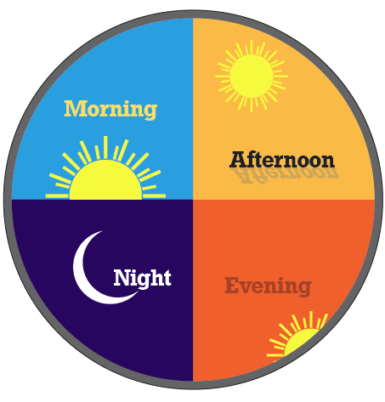
Introduce another key message and Action plan guide/Activity to promote with men | Instruction: Introduce another key message… and formulate action plans. Once this has been done, continue with exercise below.  Instruction: Count the ballots in the blue box and then the black box and share the results with the participants. Compare these results with the last 2 week’s results and discuss whether hand washing with soap is improving in the community. Congratulate mothers if the situation has improved!  Promoter: “Think about where we are now compared to where we were at the time of the first session. Are we, our families and communities where we want to be in regards to hand washing with soap? In other words do our hands have magic in them? If not, think about what we need to do to become more like the Magic Mum in the story? Think about all the things we have discussed today including some of the challenges you faced in achieving the goals we set in our action plans last time. Think about some of the things we discussed in overcoming those challenges. Let’s agree to take action to overcome those challenges over the next few weeks and we will continue to follow up. If you are able to overcome the challenges and do your best to ensure you and your family wash hands with soap, we will have a small celebration and give you a token of appreciation for participating in the program.  Instructions: Ask if anyone has any questions or issues that they would like to discuss before the session ends. Remind everyone to bring their scratch cards to the next session. Then thank the mothers for their participation and confirm the time and date for the next meeting.  Before, the end of the session, encourage the women to encourage their men to do role play competition on two fingers two occasion key times for handwashing.  Closing remark: “Remember you have magic in your hands and your magic hands set the example for your children so that they too can grow up to have magic in their hands!” | Resources  Pen, notebook  (to take notes)
End

