SESSION 2
INTRODUCTION/ICEBREAKER:  Circle of Cleanliness | Introductions and welcome back!  Instruction: Use coloured powder to make a large circle, large enough to allow all participants to sit comfortably inside. Ensure the area is clean and neat. You can also put down a mat or blanket to sit on if appropriate. Invite some of the mothers to help create the design as well.  Promoter: “Mothers, this beautiful circle that we have drawn isn’t just any circle, imagine from this moment on it’s a very pure and clean place”.  So, only pure mums with magic hands can enter. What does it mean to have magic hands”? (A: Clean hands washed with soap and water). So who then amongst us do you think can enter the circle? Can you enter madam? Can you….maybe you there…?”  Instruction: Try to get mothers to share who they think can enter and why. “For those who are not ready to enter, what would you need to do in order to have magic hands”?  Instruction: Invite a child from the audience to sit in the center of this “circle of cleanliness”.  Promoter: “I need one young volunteer to come and sit into this special, magical circle of cleanliness. Is there any boy or girl who would like to do this? Yes? Fantastic! What is your name?” “Mothers, what does (name of child) need to do before coming into the circle of cleanliness and purity?” (Answer: Wash hands with soap and water).  Instruction: Once the child has volunteered, washed his or her hands with soap and is sitting in the circle, invite his/her mother to come forward. Give her a small food item for the child. Ask the mother:  Promoter: “Ms. ______ (mother’s name) would you like to go into the circle and feed _______(Child’s name) a snack?” “_____ (child’s name) would you like a snack?”  “Mothers, what should we do before entering a pure, clean place? What should we do to ensure our hands have magic in them before handling food?” (A: wash hands with soap and water).  Instruction: Get the mother to wash her hands with soap and water. Get everybody to applaud when she does this. Then allow her to enter and feed the child and get the audience to clap and appreciate this beautiful moment.  Promoter: “Isn’t this a beautiful moment?!”  Audience: – Yes!  Promoter: “Aren’t children pure, clean and beautiful?”  Audience – Yes!  Promoter: “Don’t forget, we must purify our hands to ensure they have magic in them before feeding or breastfeeding our children every day by washing our hands with soap and water. Do you agree?”  Audience – Yes!  Promoter: “What are the other important hand washing times we need to remember in order to ensure our hands have Magic in them?” (Probe for key times).  “Every day when you are with your children, please remember to wash your hands with soap, especially after you use the toilet or after you change their nappies to come back into the circle of purity and cleanliness”.  “Will you remember this?"  Audience – Yes!  “The circle of cleanliness represents a space where magic mums with magic hands can comfortably sit. Just as the Magic Mum in the story, you too can become a Magic Mum by ensuring your hands always have magic in them!”  Instruction: At this point, all mothers and their children can be invited to share a snack in the circle of cleanliness ensuring they wash their hands with soap and water before entering. | Resources  Promoter implementation guide/script Session 2  Coloured powder to make a circle  Large blanket or mat to sit on  Snacks for all participants (including children)  Bucket with tap (for hand washing), soap, water  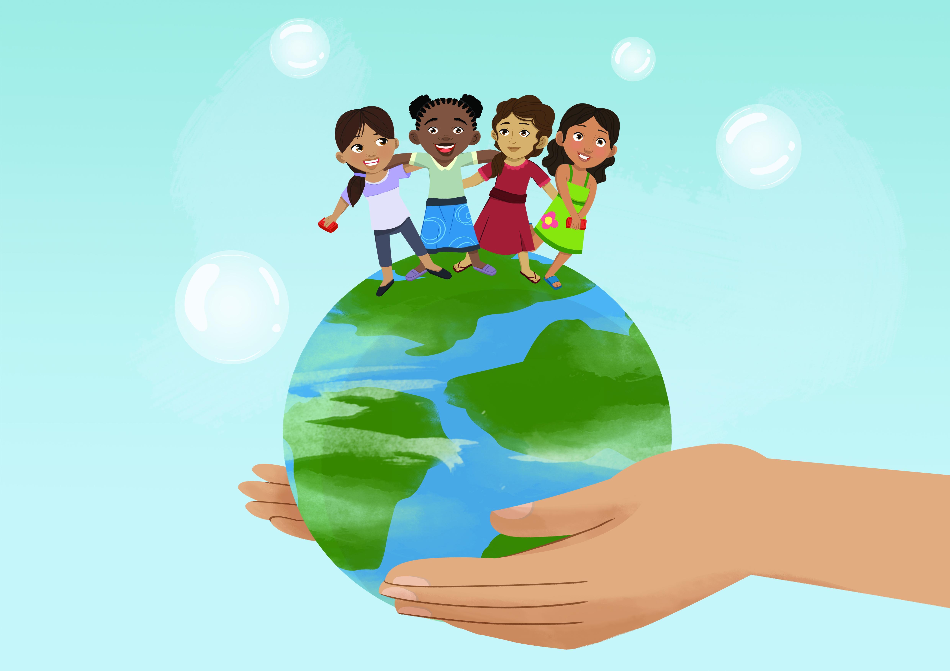
RECAP from last session and follow up on action plans | Promoter: “Now that we are all comfortable and clean in our circle of cleanliness, can anyone tell me what we discussed during our last session?” (Get mothers to share what they recall from previous session).  “What were the main messages of a Mum’s Magic Hands”? (Probe for 2 key occasions - before contact with food and after contact with faeces - and other key times that fall under these occasions:  Before contact with food includes: Before eating, preparing food, before feeding children and before breastfeeding.  After contact with faeces includes: After using the toilet, after cleaning child faeces.  Promoter: “Were there any other messages that you remember?” (Answers could include nurturing children; ensuring children develop good habits early in life; ensuring children have the best chance for success as they grow, etc.).  Promoter: “Now let’s reflect on our action plans from last week/last session. Is there anyone who would like to remind us what we planned to do to ensure the best hand washing environment in our homes? (Probe for the action plan items that were recorded the previous week).  Instruction: Ask mothers what actions they took at the household level to ensure they and their families were reminded of hand washing with soap at key times.  Promoter: “What actions did you take in your home to be a “Magic Mum” so that you and your children remembered to wash hands with soap like the mother and daughter in the story we shared last week?”  Instruction: Answers could include: placing stickers near toilet, cooking and eating areas, setting up hand washing facilities at home, ensuring soap and water were available and accessible to all at all times, ensuring young children washed hands with soap, set good hand washing example in front of children, scratch card exercise with children, etc.  Promoter: “Was anyone not able to follow through with any of the actions? Why? What are some of the challenges you faced in ensuring you and your family’s hands had magic in them?  Remind mothers of the scratch card exercise and ask if they’ve brought them to the session. If so, review last week’s progress (boxes 1-7 ONLY). Discuss why on some of the days, the box is still intact or why more than required have been scratched off?  Instruction: Discuss challenges (i.e. why they did not practice hand washing with soap on a particular day) and ways to overcome them. | Resources  Magic Hands Storyboard  Action plans from last session  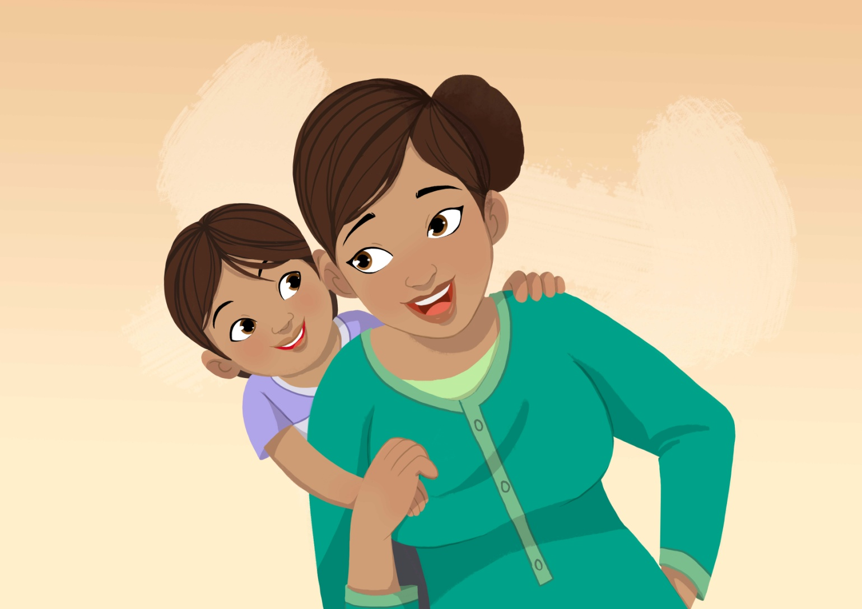
Monitoring exercise | Instruction: Set up the 2 boxes in a discreet place where people can vote anonymously. You can put the boxes behind a curtain or in an appropriate place hidden away from the group so that they are not seen depositing their votes. You will use this in an exercise following the questions.  Promoter: “Remember the exercise we did during the last session with the hand washing box and the non hand washing box? We would like to conduct this exercise again.  Instruction: Distribute 5 ballots to each mother.  Promoter: “As in session 1, we have set up 2 boxes; one blue one and one black. Remember, the blue box is the ‘HWWS soap and represents hands that have magic in them’ and the black one is the ‘non HWWS box and represents hands that are lacking the magic’.  PART 1: Now I’d like you to think about mothers in your community. For those of you who think mothers have magic in their hands before eating (i.e. are washing their hands with soap regularly at this key time), please place your ballot in the blue box or the ‘HHWS box’. For those of you who think that other mothers in your community lack magic in their hands before eating (not washing their hands with soap regularly on this key time), please place your ballot in the black box or the ‘non hand washing with soap box’.  PART 2: Again think about mothers in your community and their hand washing practice after using the toilet. For those of you who think mothers have magic in their hands and are washing their hands with soap regularly after using the toilet please place your ballot in the blue box or the ‘hand washing with soap box’. For those of you who think that mothers in your community lack magic in their hands or are not washing their hands with soap regularly after using the toilet, please place your ballot in the black box or the ‘non hand washing with soap box’.  PART 3: Again think about other mothers in your community. For those of you who think other mothers are washing their hands with soap regularly before feeding babies or young children please place your ballot in the blue box or the ‘hand washing with soap box’. For those of you who think that other mothers in your community are not washing their hands with soap regularly before feeding babies or young children, please place your ballot in the black box or the ‘non hand washing with soap box’.  PART 4: Again think about other mothers in your community. For those of you who think other mothers are washing their hands with soap regularly before preparing food place your ballot in the blue box or the ‘hand washing with soap box’. For those of you who think that other mothers in your community are not washing their hands with soap regularly before preparing food, please place your ballot in the black box or the ‘non hand washing with soap box’.  PART 5: Again think about other mothers in your community. For those of you who think other mothers are washing their hands with soap regularly after cleaning child faeces please place your ballot in the blue box or the ‘hand washing with soap box’. For those of you who think that other mothers in your community are not washing their hands with soap regularly after cleaning child faeces, please place your ballot in the black box or the ‘non hand washing with soap box’.  Instruction: Count the ballots in the blue box and then the black box and tell the participants you will follow up at the end of session. | Resources  Notetaker  Ballots – 5 per participant  1 Blue Box with hole for voting cards  1 Black Box with hole for voting cards
Mum’s Magic Hands Storyboard Refresher | Instruction: Review “Mum’s Magic Hands” Storyboard by showing the group each image from the story one at a time. Ask them to describe the scene. Help them to remember if they forget any key points. | Resources  Mum’s Magic Hands Storyboard
Magic Hands Participatory exercise | Instruction: Show the last scene where the daughter is embracing her old mother.  Promoter: “Now let’s think about our own mothers. Does anything the story remind you of your mothers from your childhood? Did food from your mother’s hands taste special? Did your mothers have Magic Hands? Did you receive the magic? Do all mothers have magic hands?  Instruction: Once the audience agrees, we ask all those who have magic hands to raise their hands.  Get them to raise them high.  “How much magic do we have in our hands? This much?”  Instruction: Raise your hands half way.  “Or this much?”  Instruction: Raise your hands as high as you can.  Promoter: “What happens to the magic hands when we don’t wash them with soap?” Does it affect the magic? Does it go down?”  Instruction: Drop your hands a little when they say it does.  The promoter rhetorically repeats – ‘So what will happen if we don’t wash our hands with soap after using the toilet?’  Instruction: Drop your hands a little.  Promoter: “So what will happen if we don’t wash our hands with soap before eating?”  Instruction: Drop your hands a little more.  Promoter: “So what will happen if we don’t wash our hands with soap before feeding or breastfeeding our children?”  Instruction: Drop your hands a little more.  Promoter: “So what will happen if we don’t wash our hands with soap before preparing food for our families?”  Instruction: Drop your hands a little more.  Promoter: “So what will happen if we don’t wash our hands with soap after cleaning child faeces?”  Instruction: Drop your hands a little more.  Instruction: Once the hands are down, we do the reverse.  Promoter: “But what happens when we wash hands with soap? The magic goes up….  Promoter: “So what will happen we wash our hands with soap after the toilet?”  Instruction: Raise your hands a little  Promoter: “So what will happen if we wash our hands with soap before eating?”  Instruction: Raise your hands a little more  Promoter: “So what will happen if we wash our hands with soap before feeding or breastfeeding our children?”  Instruction: Raise your hands a little more  Promoter: “So what will happen if we wash our hands with soap before preparing food for our families?”  Instruction: Raise your hands a little more  Promoter: “So what will happen if we wash our hands with soap after cleaning child faeces?”  Instruction: Raise your hands until they are as high as they can go  Promoter: “So are you going to protect your magic?”  Audience: (Chorus) Yes!  Promoter: “So are you going to pass on your magic to your children?”  Audience: (Chorus) Yes!!  Promoter: “So are you going to wash your hands with soap?”  Audience: (Chorus) Yes!  Promoter: “Are you going to wash your hands with soap before contact with food and after contact with faeces?”  Audience: (Chorus) Yes!  Promoter: “Thank you for being a wonderful mother. Remember to set a good example for your children because they mirror what we do. So always wash your hands with soap.” | Resources  Frame 16: Final sign off mum  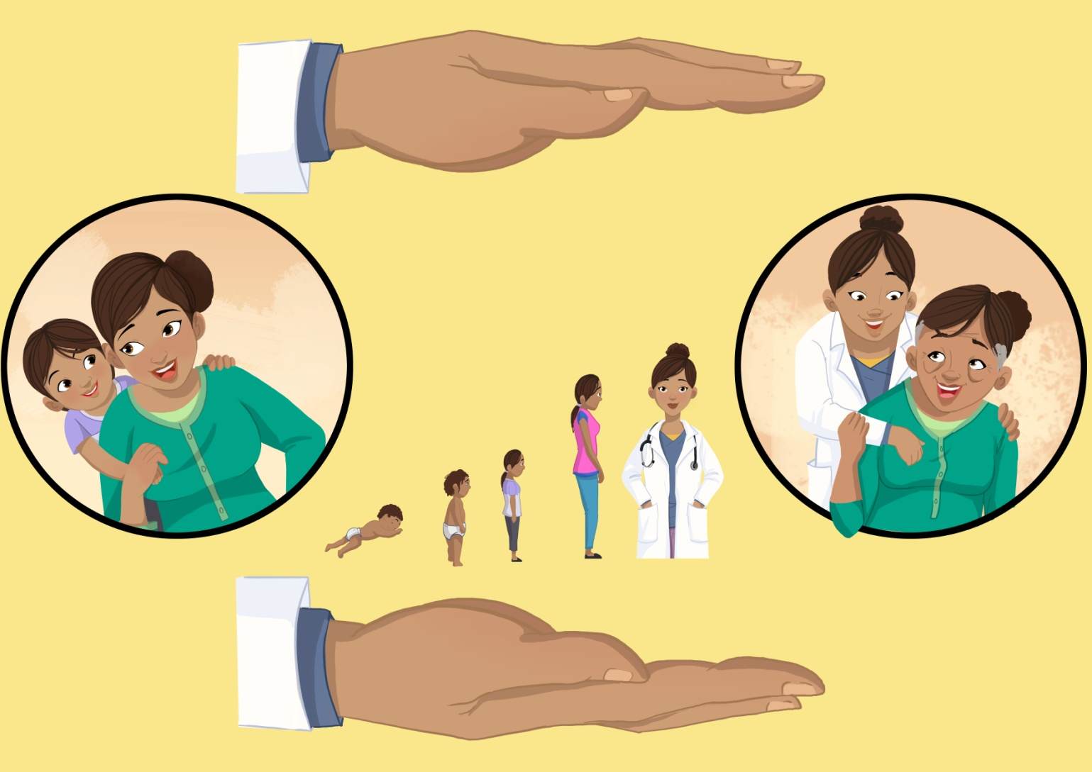
Bed Time Tale | Instruction: If mothers did not mention the Bed Time Tale exercise in their action plans above, remind them. Show frame 13 which shows the mother putting the child to sleep in the story. Ask mothers again to explain this frame. Probe: What is the mother in this frame doing? Does she have magic in her hands? Why?  Promoter: “Who would like to be the first one to share their Magic Mum story or role play with the group? Do we have any volunteers?”  Instruction: Listen to the stories or role plays of each mother or pairs of mothers and ask mothers to listen carefully as they will be asked to vote for their favourite at the end.  Promoter: “Thank you for sharing your wonderful stories. I will remember these and tell them to my own children! Mothers, let’s take a moment to vote for your favourite one.”  Instruction: Mothers can either vote in front of each other by raising their hands or anonymously. Ask them which they prefer. Once mothers have voted, tally up the votes and declare the winner. Present the winner with a prize. Explain the purpose of the prize to the winners. i.e. “This mirror is a very special mirror. Each and every time you look into it you will be reminded of the Magic Mum in the story and the 2 key occasions for hand washing with soap.” | Resources  Frame 13: Sleep and Success  Prizes for best story (e.g. Magic Hands puzzle/compact mirror)  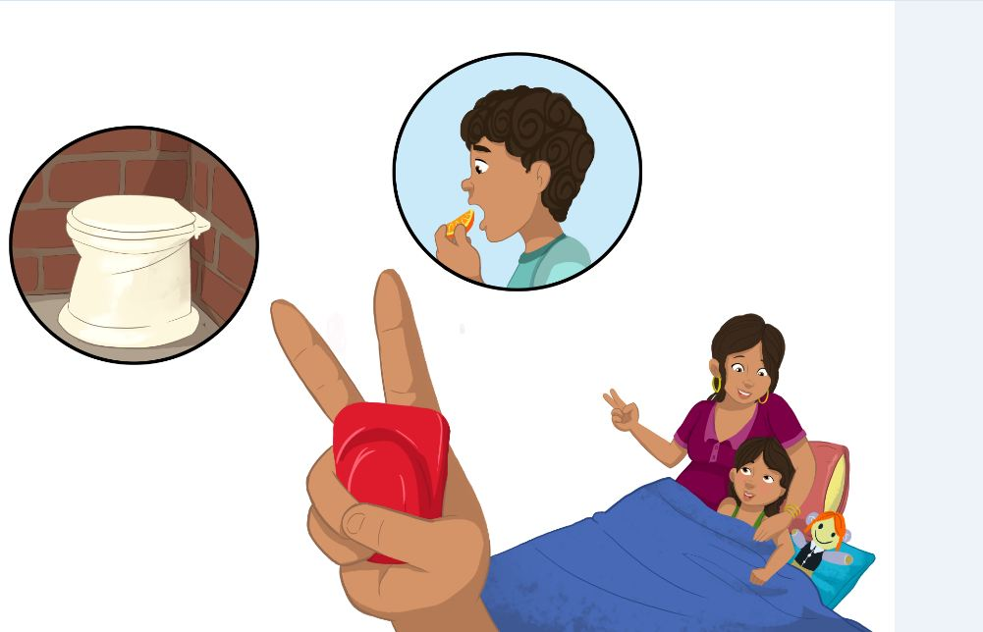
What Goes Around | Instruction: Show mothers Frame 9 (Behavioural manners). Ask them what is happening in the frame.  Promoter: “Please look closely at this frame and tell me what is happening? Do you recognise this image? Does it remind you of what happens in your community? What do you think these women are saying to the girl? How does it make you feel?  Probe: “Why do you think they are appreciating the child and her mother?”  “What qualities do you appreciate in a child?”  “What does it tell about the mother?”  “Do you appreciate mothers like this?”  “Do you know any mothers in the group who is like this? Would you say they have magic hands?”  Instruction: Ask that person and her child to stand up. Have everyone applaud.  Promoter: “Is there anyone in the group that you appreciate. Other than the person that nominated you?”  Instruction: Continue this exercise for awhile longer then finish up.  Promoter: “Now I’d like all of you to stand up. All of you have magic in you, in your hands. So we need to put our hands together for all mums and their magic hands (clap or high 5!). Remember to wash your hands with soap to retain their magic ... because all of us are magic mums and we all use soap to wash our hands!”  Note: Could also do this exercise as a role play e.g. have one mother play the role of the mum, and 2 others can play the role of the older woman and the younger woman. | Resources  Frame 9: Behavioural manners  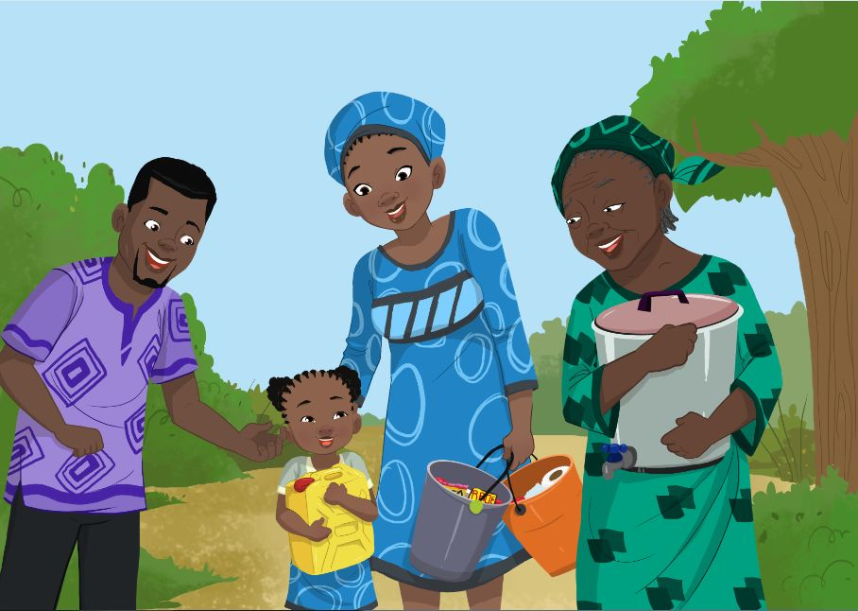
Introduce another key message and Action plan guide | Instruction: Introduce another key message and formulate action plans. After this has been done, continue with the exercise below.  Instruction: Count the ballots in the blue box and then the black box and share the results with the participants. Compare these results to last week’s results and discuss whether hand washing with soap is improving in the community. Congratulate mothers if the situation has improved!  Promoter: “Think about where we are now compared to where we would like ourselves, our families and our communities to be in regards to hand washing with soap. In other words do our hands have magic in them? If not, think about what we need to do to become more like the Magic Mum in the story. In other words are we Magic Mum’s? Think about all the things we have discussed today including some of the challenges you faced in achieving the goals we set in our action plans last time. Think about some of the things we discussed in overcoming those challenges. Let’s agree to take action to overcome those challenges by (date/next session) so that we can all be Magic Mums (use mother’s ideas on overcoming challenges). This will be your hand washing assignment for this week!”  Instruction: Ask if anyone has any questions or issues that they would like to discuss before the session ends. Remind everyone to bring their scratch cards to next week’s sessions. Remind them to bring their children along as well as there will be a fun game that we will do with children. You may have to change the timing based on availability of children (8 years and under). Then thank the mothers for their participation and wish everyone a great week and Happy Hand Washing! Don’t forget to confirm a time and date for next week’s meeting.  Closing Remark: “Remember you have magic in your hands and your magic hands set an example for your children so that they too can grow up to have magic in their hands too!” | Resources  Markers, Flip chart paper
End

